

**AMERICAN INTERNATIONAL UNIVERSITY- BANGLADESH**

**(AIUB)**

**Introduction to Electrical Circuit**

**FALL 2023-2024**

**Section: L, Group: 07**

**LAB REPORT ON**

***Study of ‘Nodal Analysis’ in R-L-C combination circuit in AC* Supervised By**

**MD. SHAHARIAR PARVEZ**

|  |  |
| --- | --- |
| **Name** | **ID** |
| **1.MD. Abdullah** | **22-48065-2** |
| **2.Azmir Islam Kafi** | **22-47981-2** |
| **3.Mohammad Ansar Uddin** | **22-47975-2** |
| **4.Chinmoy Guha** | **22-48056-2** |
| **5.Suvra Chakraborty** | **22-48067-2** |

***Abstract:***

The purpose of the experiment was to develop an understanding of the method of determining voltage and current using 'Nodal Analysis' in an R-L-C AC circuit. Circuits containing R, L, and C components were constructed, and the objective was to analyze the outputs of R-L-C series-parallel combination circuits to obtain practical values as well as simulated or theoretical results. Additionally, the experiment involved determining the phase relationship between V and I in an R-L-C combination circuit and drawing a complete vector diagram to comprehend the method of using Nodal analysis.

***Circuit diagram:***

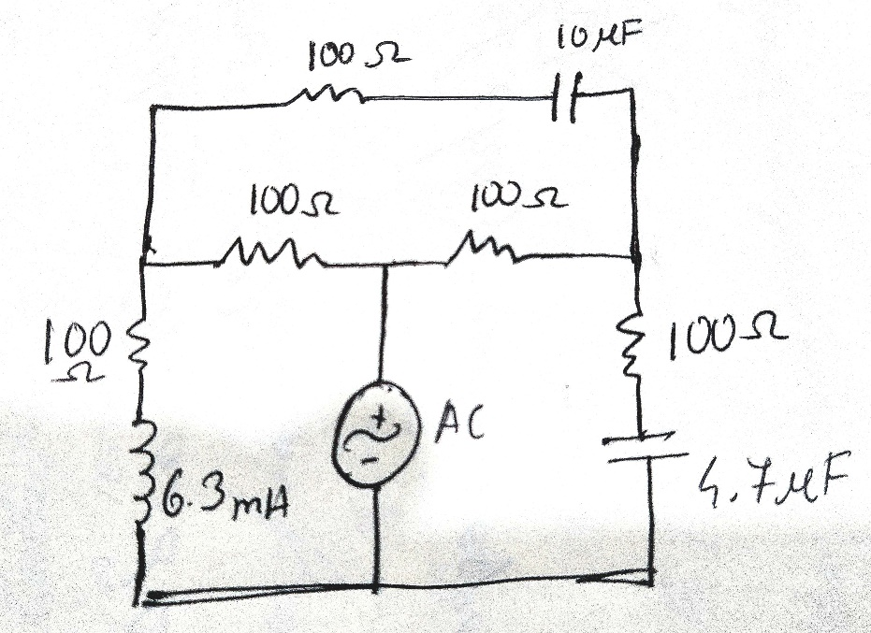

***Figure 1: Circuit diagram for Nodal Analysis***

**Apparatus:**

1. Oscilloscope, b) Function generator c) Resistor: 100 ohm - 5 pcs d) Inductor: 6.3 mH e) Capacitor: 4.7 microF and 10 microF, f) Connecting wire, g) Bread board

***Experimental Procedure:***

The circuit illustrated in Fig. 1 was successfully constructed, with channel 1 of the oscilloscope connected across the function generator and channel 2 across R2. The amplitude of the input signal was set at 10V peak, and the frequency was adjusted to 1 kHz, with a sinusoidal wave shape selected. Measurements were taken for the values of VA and the current IV A-B. The phase relationship between the supply voltage V and the node voltage at VA was determined. Subsequently, channel 2 of the oscilloscope was connected across R3, and the phase relationship between the waves was determined. The values of VC and IV B-C were measured, and the phase relationship between the supply voltage V and the node voltage at VC was determined. Further analysis involved determining IV A-C, IV A-G, and IV C-G. All the obtained currents were compared with their theoretical values, and the percentage error was calculated for comprehensive assessment..

***Result analysis :***

**Data Table:**

|  |  |  |  |  |  |  |  |  |  |  |  |  |
| --- | --- | --- | --- | --- | --- | --- | --- | --- | --- | --- | --- | --- |
| Freq.(f) (kHz) | Supply Voltage (V) | Practical Value | | | | | | | | | | Error |
| IV B-A | | IV B-C | | IV A-C | | IV A-G | | IV C-G | | %Error= (Theoretical – Practical  value/Theoretical value) *100 |
| Mag.  IVB-A (mA) | Pha se θ (o) | Mag. IV B-C  (mA) | Pha se θ (o) | Mag. IV A-C  (mA) | Pha se θ (o) | Mag. IV A-G  (mA) | Pha se θ (o) | Mag. IV C-G  (mA) | Pha se θ (o) | % |
| 1kHz | 7.07Vrms | 66.964 | -3.34 | 68.212 | -3.34 | 134.605 | 1.2 | 69.874 | -24.74 | 69.731 | 15.2 | 5% |

***Simulation:***

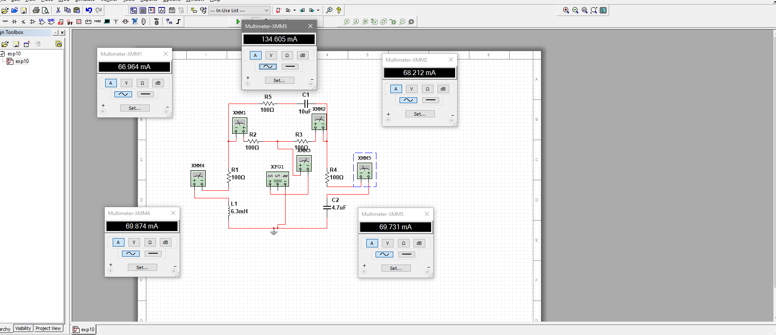

***Figure: Currents for the circuit.***

***Calculation:***

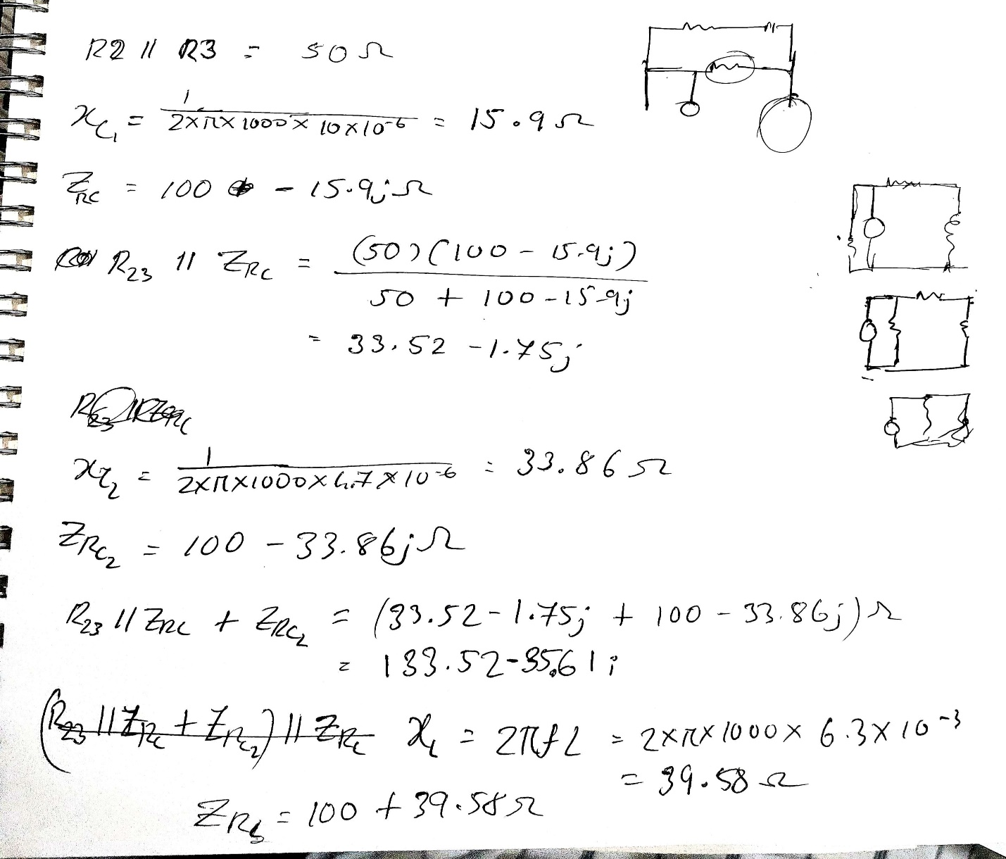

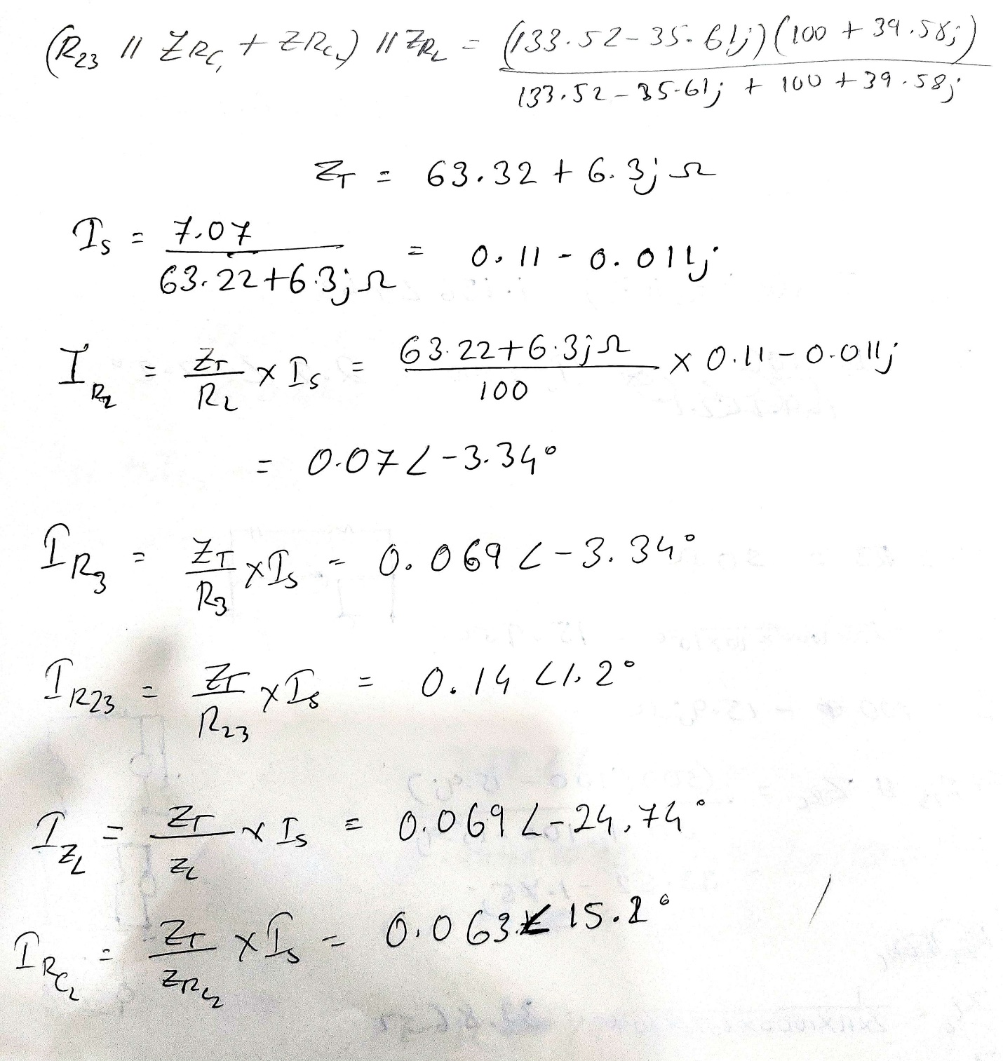

***Discussion***

The purpose of the experiment was to develop an understanding of the method of determining voltage and current using 'Nodal Analysis' in an R-L-C AC circuit. Circuits containing R, L, and C components were constructed, and the objective was to analyze the outputs of R-L-C series-parallel combination circuits to obtain practical values as well as simulated or theoretical results. Additionally, the experiment involved determining the phase relationship between V and I in an R-L-C combination circuit. All of these were successfully demonstrated and found. The phase of each I was calculated through theoretical calculations and we found that there was a bit of a difference between the calculated values and practical values.

***Conclusion:***

By completing this experiment we had become familiar with the method of determining voltage and current using Nodal Analysis in an RLC AC circuit.